CREATING PIPELINE LENGTHS REPORT

- Create report by filter named “Shaw Piping Pipelines Length” THAT uses Query name = PIPERUNS and catalog filter ShawPipingRuns with following properties:
  - On system tab check “User of filter supplies values”
  - Object type tab set to Piping>Piping Runs
- Insert PropertyName = Name / Alias Name = Name
- Formatting Report Template tab can be left undefined, all that is needed is the core report files for modification
- Save report by selecting File>Save Report Template
- Exit the Edit Template mode, right click on the report and select Copy to Catalog
- Go to report’s folder in the Symbols share and replace files with extensions .rfm; .rfp; .rqe; .rtp etc. with the ones sent from Intergraph. (save original to another folder or zip archive)
NOTE: You must edit the .rqe file to use filter “ShawPipingRuns” and make sure the report Query name is PIPERUNS.
- Create a new report using this report format from catalog as your source template
- Open the report in SP3D. Note that the query form “PIPERUNS” should indicate that it cannot be edited, this is due to the manual mod’s performed in the previous steps
- Select the Formatting tab and enter the edit mode in Excel
- Right click the report root and pick Properties
- Set the header start/end as needed
- Pick the custom macro for “Hide or Display Rows” activation
- Set fill mode to Insert values…
- Add PIPERUNS query from Report Items Available and OK
- Right click PIPERUNS and pick Properties
- In Group tab activate grouping, set values as follows and APPLY:
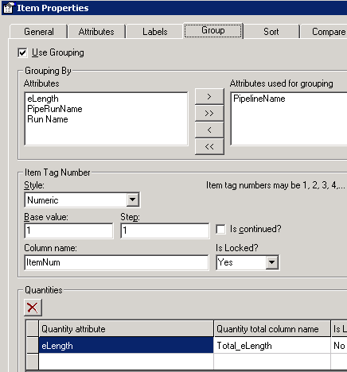
- In Labels tab create a new label
  - In Name, select more…
  - Select label Piping>Piping Pipe Length
  - Say YES to mapping inputs to current properties
  - For the Length property, select the Report Property “Total_Length” and OK
  - Set the new label line to Locked=No and Trigger = After Grouping
  - Apply
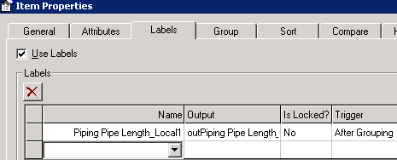
- In Sort tab select PipelineName for sorting criteria and OK
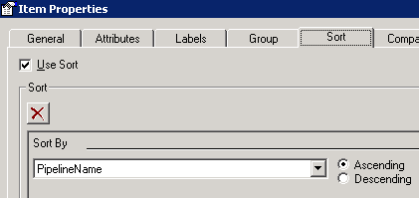
- In Excel define the format of the report
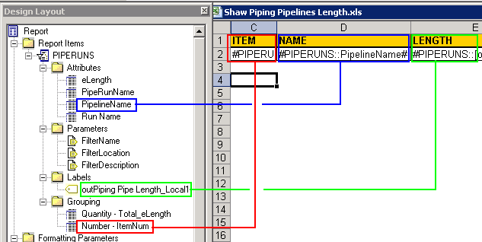
- Save and exit the report format, then save report template prior to exiting the report edit mode
NOTE: For some reason I had to save this report to Catalog, then create a report from that saved report format before the report would actually run. Test this if the above report doesn’t seem to run.
- IMPORTANT: A custom DLL was developed by Intergraph for this report. Copy SP3DReportLabel.dll to c:\program files\smartplant\3d\commonapp \client\bin
- Register (regsvr32) this dll. Repeat this on any machine where this report may need to be run
- Extract the report using Update-now

